  WOMEN & GENDER EQUALITY IN LEADERSHIP | Abstract  This segment of the Public Opinion Poll examines societal attitudes toward women in leadership and identifies structural and cultural barriers hindering their participation. Responses from diverse demographic groups across six Nigerian locations reveal that while there is significant support for women in governance, systemic challenges—such as entrenched gender norms, financial inequality, and institutional biases—continue to limit progress. The findings highlight urgent areas for intervention, including policy reforms, mentorship programs, and public awareness campaigns.

Introduction
As emphasized in the SICNI Profile, gender imbalance in leadership roles undermines Nigeria’s capacity to harness its full talent potential. Despite strong evidence of the positive impact of women leaders, the country continues to grapple with entrenched cultural norms, institutional barriers, and unequal access to opportunities. To address this, SICNI’s Public Opinion Poll incorporated a dedicated segment on women’s leadership and gender equality.
The research aimed to assess societal perceptions of women in leadership, identify the key barriers they face, and evaluate public support for gender-sensitive reforms. The survey engaged respondents in six Nigerian locations—Lagos, Enugu, Edo, Bauchi, Kano, and the FCT—using a multi-stage sampling method to ensure a balanced representation of demographic segments, including rural and urban residents, varied education levels, and both male and female perspectives. Structured 30-minute face-to-face interviews were conducted, covering attitudes, experiences, and policy preferences. The breadth of coverage ensures that the findings accurately reflect the realities facing women leaders across diverse Nigerian contexts.
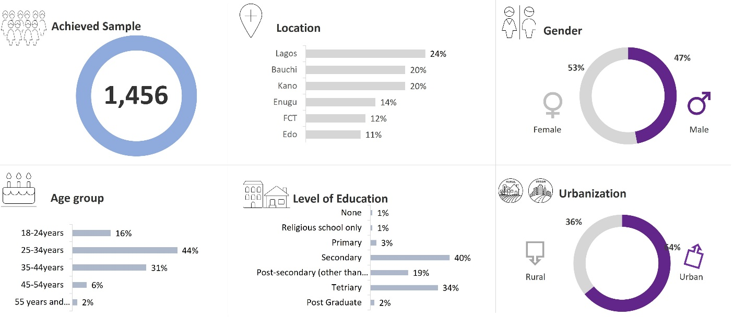
Data was collected through 30-minute structured, face-to-face interviews in strategically selected urban and rural locations, resulting in a dataset that reflects the voices of a diverse cross-section of Nigerians.

Research Findings
The survey results point to the following critical insights into the current landscape
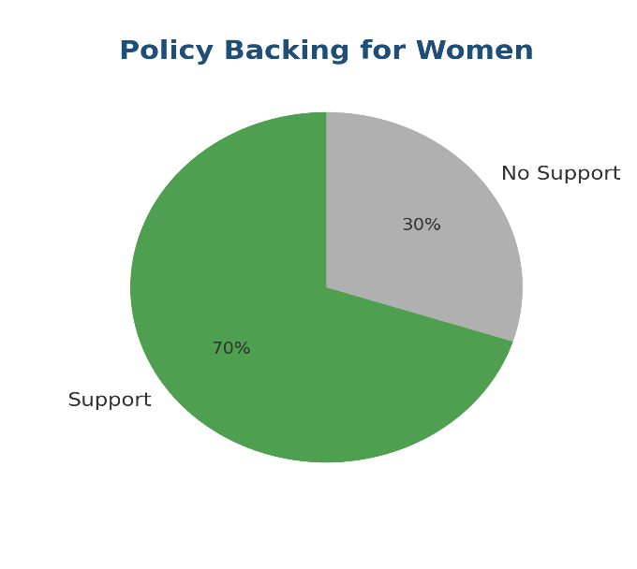
1. Policy Backing for Women
A healthy majority believe there should be stronger institutional and policy support for women aspiring to leadership roles. This indicates public openness to structural reforms.

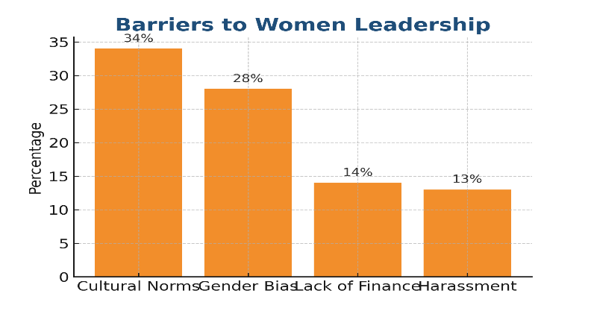
2. Barriers to Women Leadership
Cultural norms and gender bias remain the most cited obstacles to women’s advancement, followed by financial constraints and workplace harassment. These barriers highlight both social and systemic challenges.

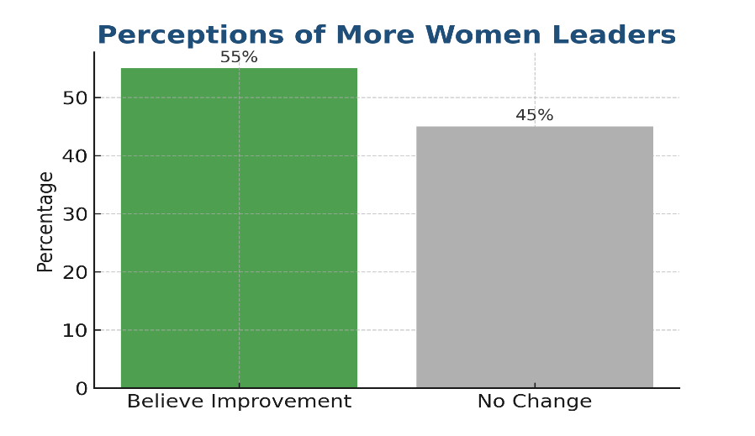
3. Positive Perceptions of More Women Leaders
Over half of respondents believe that increasing the number of women in leadership would improve governance quality, showing optimism about diversity’s impact.
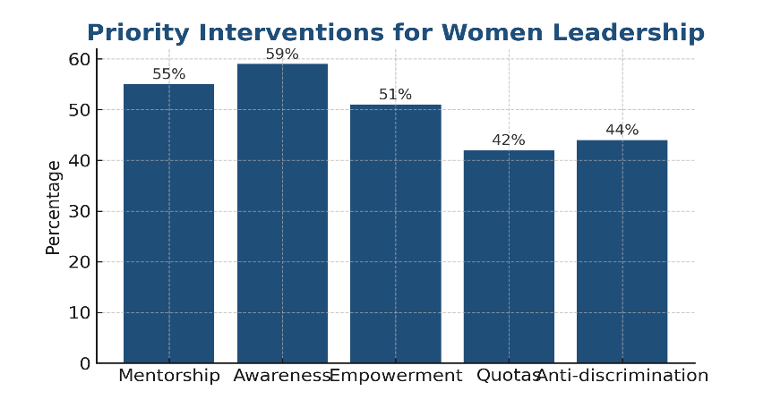
4. Priority Interventions for Women Leadership
Respondents identified mentorship programs, public awareness campaigns, empowerment schemes, and anti-discrimination laws as the most critical interventions to support women’s leadership participation.

Analysis

Despite significant societal progress, women remain underrepresented in leadership, largely due to entrenched socio-cultural norms and systemic barriers such as gender bias, financial exclusion, and harassment. The survey findings reveal both an openness to policy changes and a belief that increased female leadership would positively influence governance. This optimism is critical—it suggests public willingness to back reforms if the right strategies are presented. However, overcoming structural resistance will require both targeted empowerment programs and broader societal attitude shifts.

Proposed Intervention
In response to these findings, SICNI proposes the following actionable strategies for meaningful change:
- Women’s Leadership Incubator
 | A year-long mentorship and training initiative pairing experienced women leaders with aspiring ones, focused on skills, networking, and confidence building.
- Public Awareness Campaigns
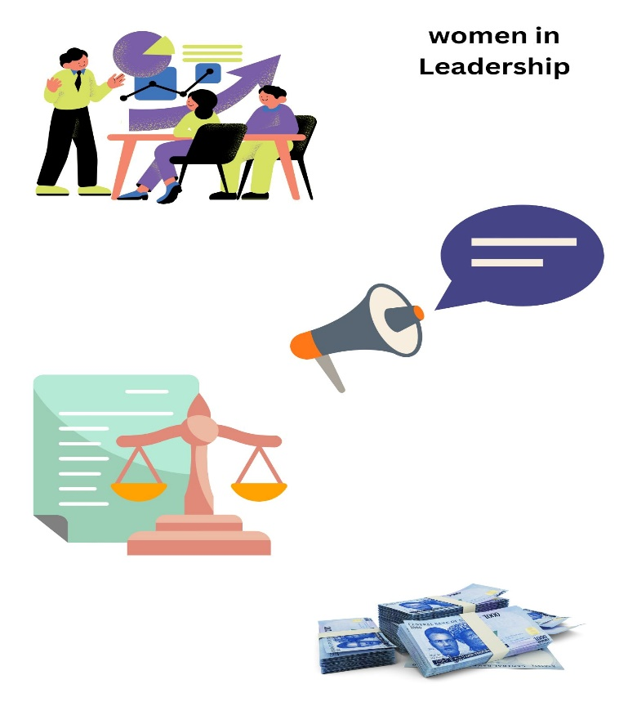 | Media and grassroots outreach to challenge stereotypes and normalize female leadership.
- Legal & Policy Advocacy
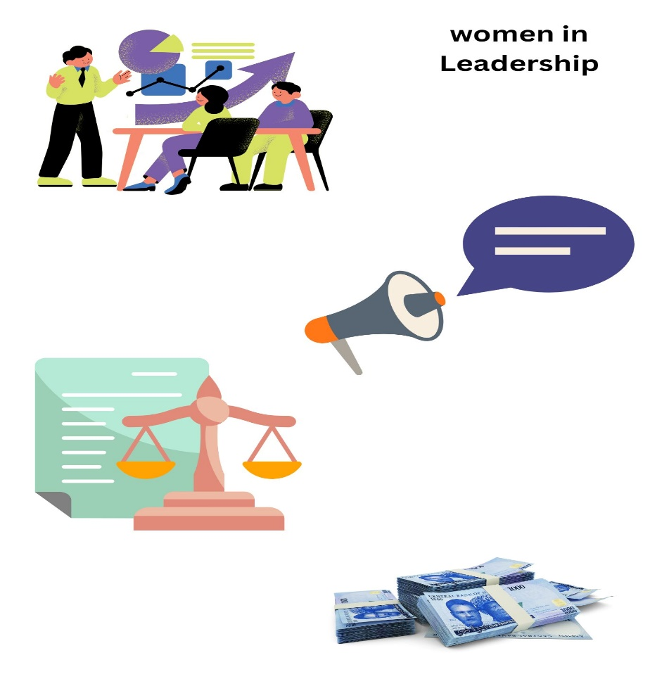 | Lobbying for stronger anti-discrimination laws, maternity and parental leave policies, and gender quotas where applicable.
- Micro-grants for Women Candidates
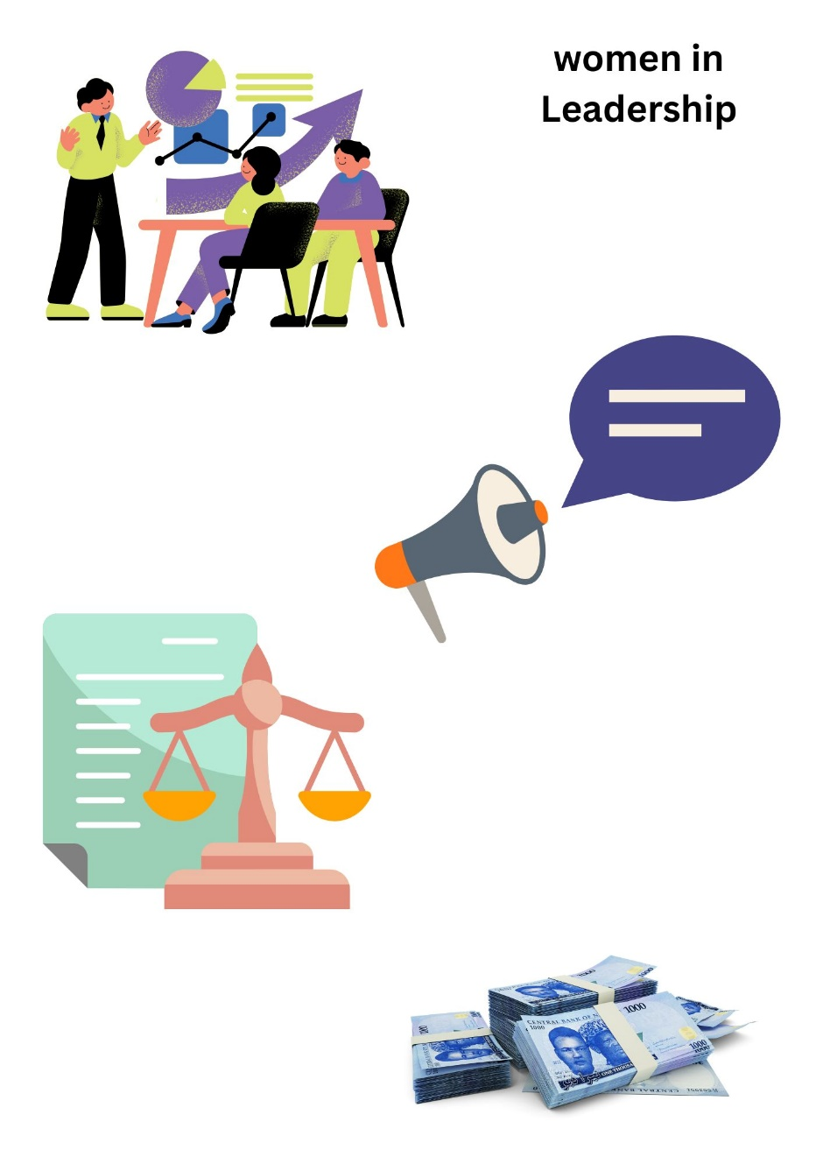 | Providing seed funding to women running for leadership roles, especially at local government and community levels.

